Assignment-3.5

Name: T Meghana
HT.No: 2303A510H4
Batch- 23
Ques on 1: Zero-Shot Promp ng (Leap Year Check)
Write a zero-shot prompt to generate a Python func on that checks whether a given year is a leap year.
Week2 -
Task:
- Record the AI-generated code.
- Test with years like 1900, 2000, 2024.
- Iden fy logical flaws or missing condi ons.
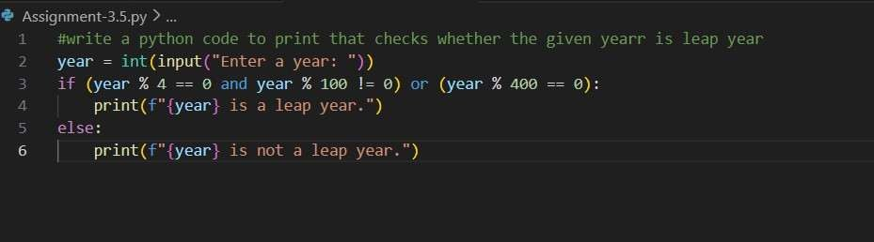
Output:
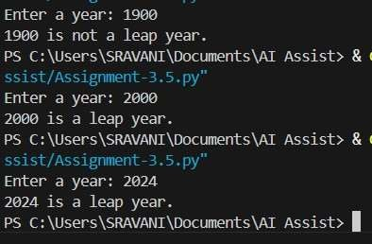

Ques on 2: One-Shot Promp ng (GCD of Two Numbers) Write a oneshot prompt with one example to generate a Python func on that finds the Greatest Common Divisor (GCD) of two numbers.
Example:
Input: 12, 18 → Output: 6
Task:
- Compare with a zero-shot solu on.
- Analyze algorithm efficiency.
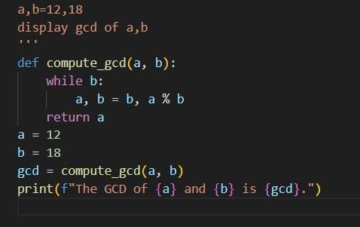
Output:
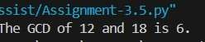
Ques on 3: Few-Shot Promp ng (LCM Calcula on)
Write a few-shot prompt with mul ple examples to generate a Python func on that computes the Least Common Mul ple (LCM).
Examples:
- Input: 4, 6 → Output: 12
- Input: 5, 10 → Output: 10
- Input: 7, 3 → Output: 21
Task:
- Examine how examples guide formula selec on.
- Test edge cases.
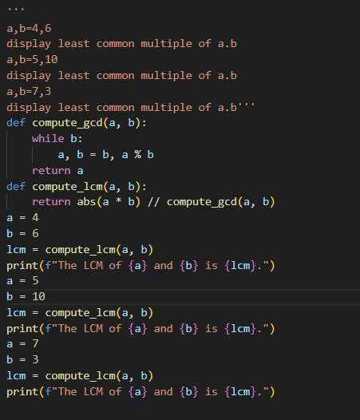
Output:
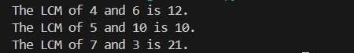
Ques on 4: Zero-Shot Promp ng (Binary to Decimal Conversion) Write a zero-shot prompt to generate a Python func on that converts a binary number to decimal.
Task:
- Test with valid and invalid binary inputs.
- Iden fy missing valida on logic.
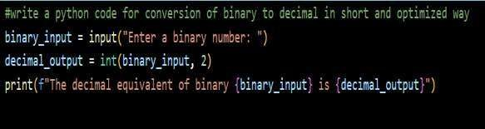
Output:
Ques on 5: One-Shot Promp ng (Decimal to Binary Conversion) Write a one-shot prompt with an example to generate a Python func on that converts a decimal number to binary.
Example:
Input: 10 → Output: 1010
Task:
- Compare clarity with zero-shot output.
- Analyze handling of zero and nega ve numbers.
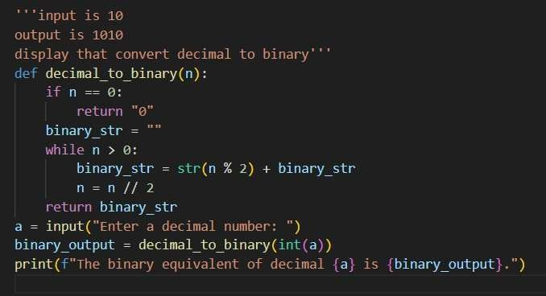
Output:
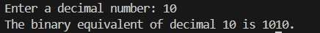
Ques on 6: Few-Shot Promp ng (Harshad Number Check)
Write a few-shot prompt to generate a Python func on that checks whether a number is a Harshad (Niven) number.
Examples:
- Input: 18 → Output: Harshad Number
- Input: 21 → Output: Harshad Number • Input: 19 → Output: Not a
Harshad Number
Task:
- Test boundary condi ons.
- Evaluate robustness
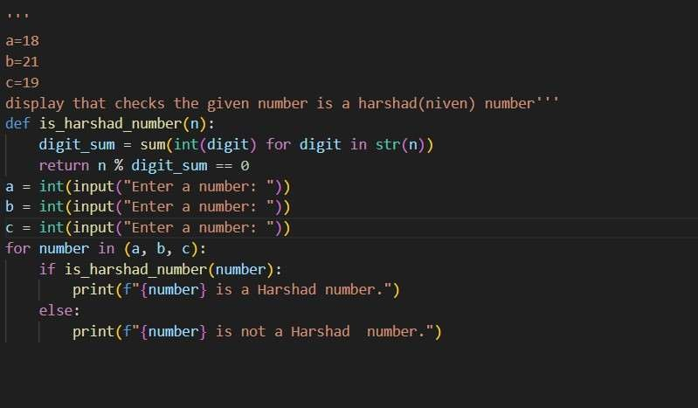
Output:
